
GROWING OUR TEAM
Join NORPAC ENGINEERING INTERNSHIP
LEARN MORE & APPLY ONLINE  www.norpacpaper.com/careers  For Questions:  CONTACT  Debbie Luchau  NORPAC Human Resources  360-636-6331  Debra.luchau@norpacpaper.com  Roberta Jacobs  Sr. Process Engineer  360-414-3525  Roberta.Jacobs@norpacpaper.com | Who We Are  These intern positions are for the North Pacific Paper Company (NORPAC), which produces printing and packaging paper for customers around the world.  What We ARE LoOking for  - Must be obtaining a degree in Pulp and Paper Science, Bio-resource science, Chemical Engineering or related field.  - Minimum sophomore standing, Strong preference given to students with a cumulative overall GPA of at least 3.0.  - We're looking for students with: integrity; academic achievement; technical ability and aptitude; commitment to continuous learning; initiative and self-motivation; teamwork ability; communication skills; problem-solving abilities; and flexibility.  - Must pass a pre-employment drug screen and criminal background check.  - We are looking a 6-month intern with the potential of an extension into a 1-year internship. The position will begin in early April 2022.  Our Business  Located in Longview, WA, this facility can manufacture more than 750,000 metric tons of printing paper annually. Interns are matched with opportunities in a variety of business and project support areas. The types of work activities available may include planning, analysis, design, development, implementation, testing, documentation, delivery, and support in several different parts of our organization.  OUr INTERN PROGRAM  As a valued member of a friendly, supportive, and professional team, interns: gain professional experience with current technology while contributing to significant projects; build communication, interpersonal, and teamwork skills essential to a successful career; and connect with people across the company to learn about career opportunities. Interns are paid for their work. In addition to a supervisor who focuses on the intern's job duties and performance, each intern has a mentor who supports his/her professional development/fa. Weekly intern activities build technical and non-technical competencies and career focus. Goal setting, individual development planning and performance feedback promote professional growth. Discover you career path at NORPAC!  This job posting will be open until Monday, March 14, 2022. Interviews will be done online starting the week of 3/14.
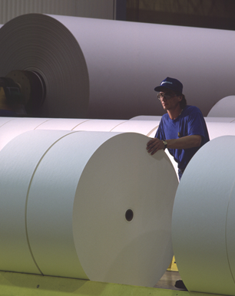
RELOCATION aSSISTANCE aVAILABLE

norpac is an Equal Opportunity Employer building a capable, committed, diverse workforce.
NORTH PACIFIC PAPER CORPORATION  BOX 2069  LONGVIEW, WA 98632-0172  (360) 636-6400 or FAX (360) 423-1514 |  | 